**Answer Sheet - SQL**

Name: Arpita S. Kurankar

Phone No. : 8767508418

Email: arpitakurankar@gmail.com

**Major Question 1**

1. List the salary of all the employees.

Select Ename, Salary from Employee

order by ename

Insert Image-

**SQL Worksheet**

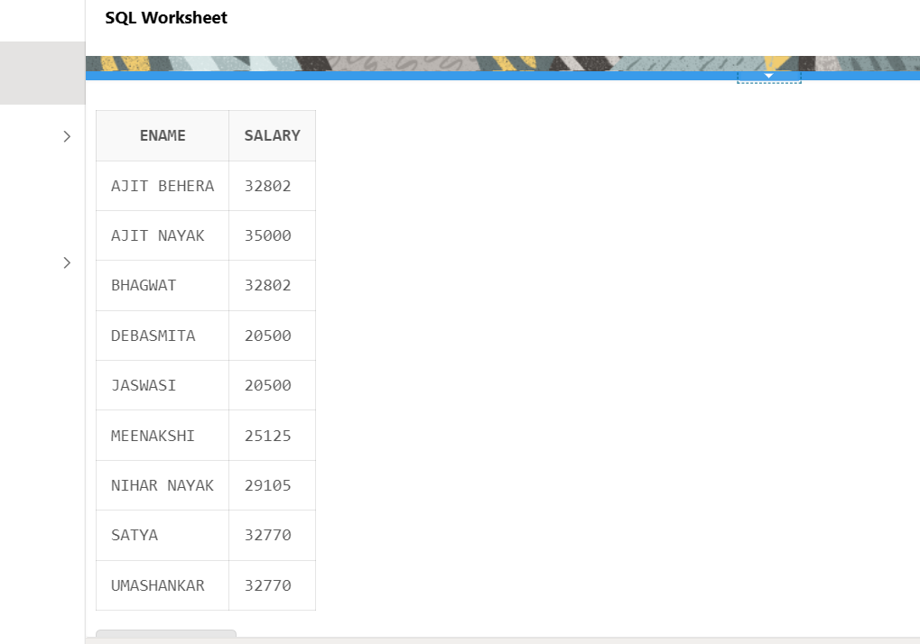

1. Display the names of all employees with any “A” at any place of the name.

SELECT *

FROM employee

WHERE ename LIKE '%A%';

Insert Image –

**SQL Worksheet**

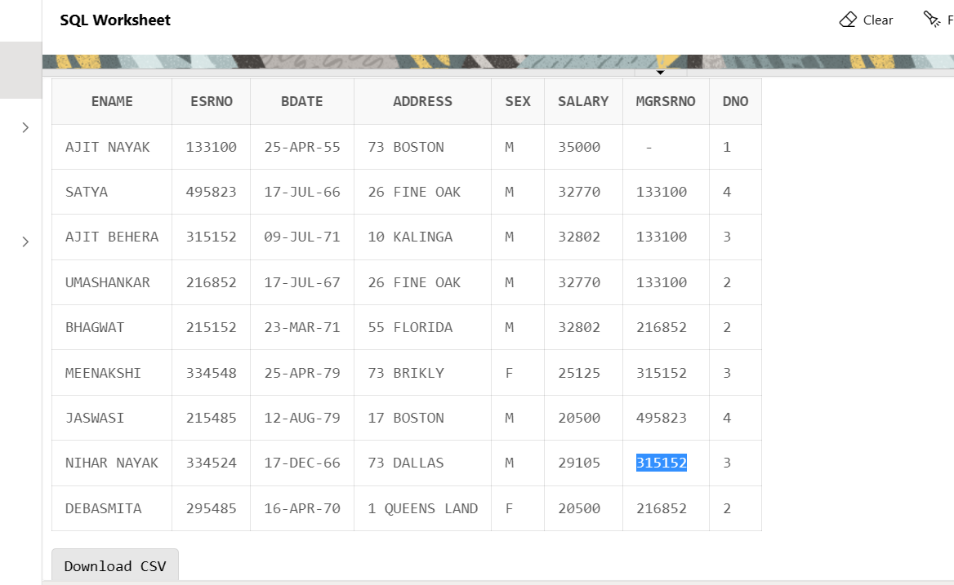

1. Show all employees who were hired in the first half of the month (Before the 16th of the month).

Select ename,MGRSTARTD

From Employee INNER JOIN Department

ON Employee.ESRNO=Department.MGRSRNO

WHERE EXTRACT(DAY FROM MGRSTARTD) < 15

Insert Image -

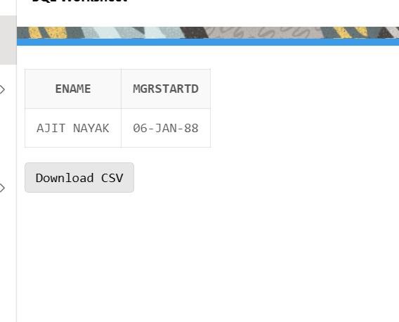

1. Display the name of all female employees.

Select Ename, Sex

from Employee

where sex= 'F';

Insert Image –

**SQL Worksheet**

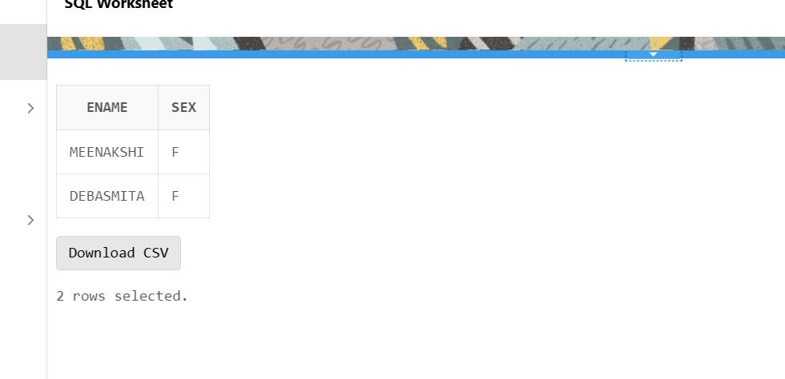

1. Display the employee who is paid most in the company.

SELECT

Ename,

Salary

FROM

Employee

WHERE

Salary =(

SELECT

MAX( Salary )

FROM

Employee

);

Insert Image –

**SQL Worksheet**

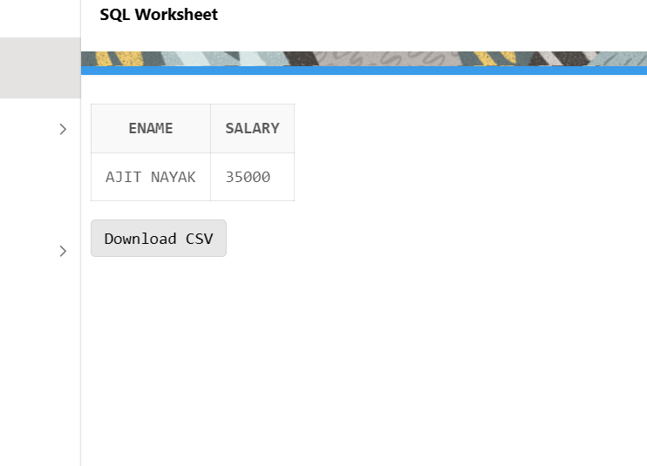

**Major Question 2**

1. Display employee name, address, department no and department name.

Select ENAME, ADDRESS, DNUMBER,DNAME

From Employee INNER JOIN Department

ON Employee.ESRNO=Department.MGRSRNO

order by ename;

Insert Image –

**SQL Worksheet**

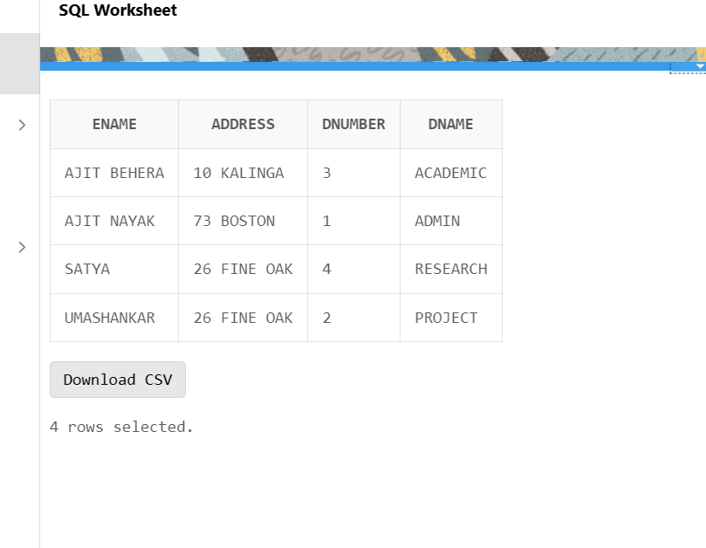

1. Display all the employees who are *not in* ACADEMIC department

Select Ename,Dname,Dnumber

From Employee,Department

Where not Dname ='ACADEMIC' And Employee.ESRNO=Department.MGRSRNO

ORDER BY ENAME;

Insert Image –

**SQL Worksheet**

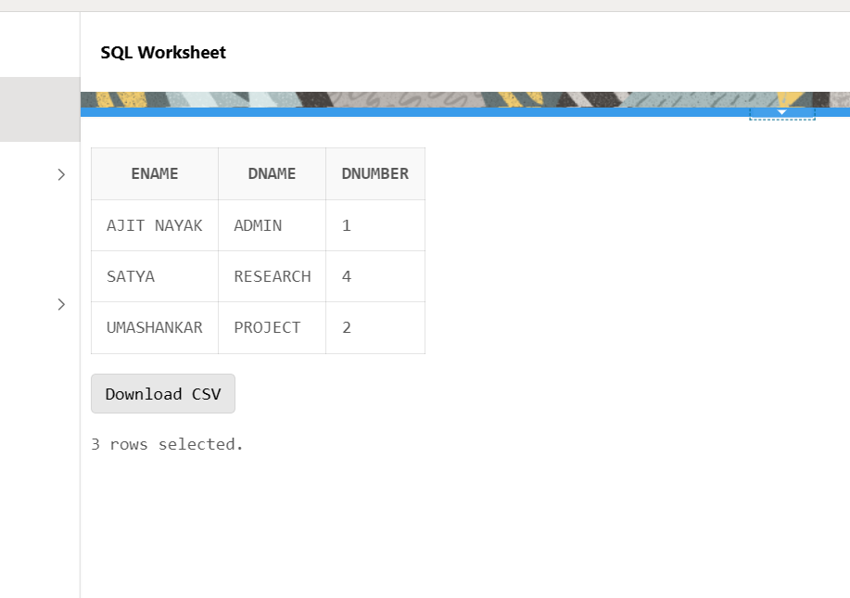

1. Display SATYAS’ project location.

Select Employee.Ename, project.Plocation

From employee

inner JOIN Works_on

ON Employee.ESRNO=Works_on.ESRNO

inner JOIN Project

on Project.pnumber=Works_on.pno

where Ename='SATYA';

Insert Image -

**SQL Worksheet**

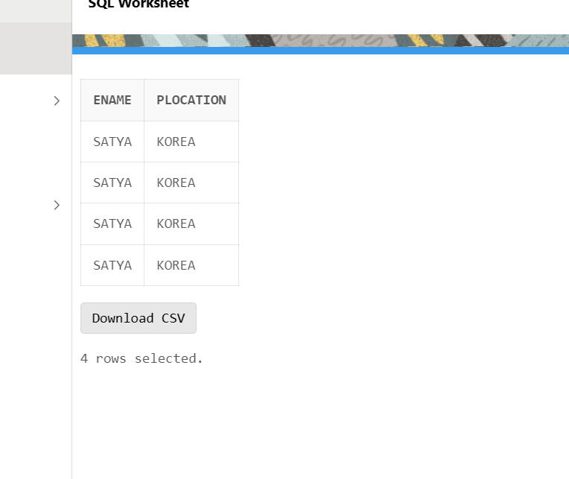

1. Find the total working hours of *each* female employee.

Select ENAME, Sex, Hours

From Employee INNER JOIN Works_on

ON Employee.ESRNO=Works_on.ESRNO

where sex='F';

Insert Image -

**SQL Worksheet**

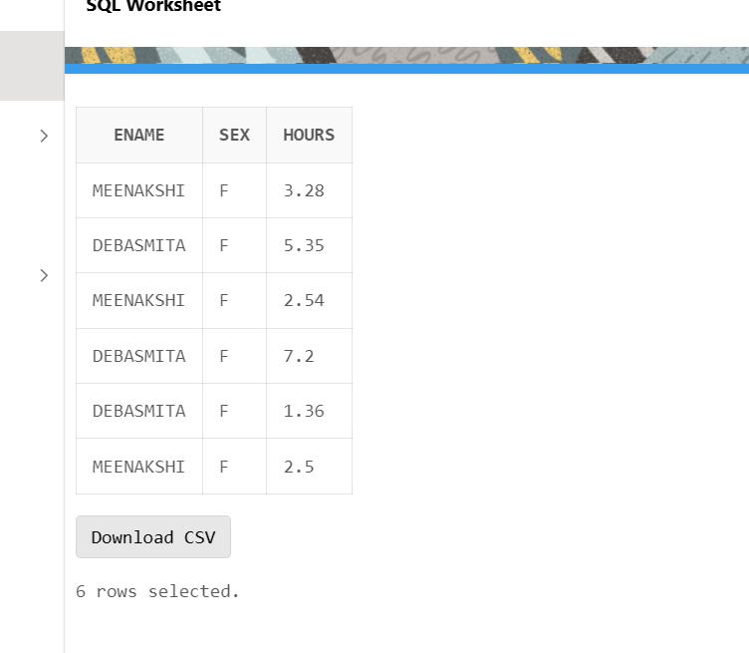

Select Ename,Employee.esrno,bdate,address,Sex,Salary,Employee.MGRSRNO,Employee.DNO, Department.DNAME,Department.DNUMBER,Department.MGRSRNO,Department. MGRSTARTD, Plocation, Pname,Pno,dnum,pno,hours,works_on.esrno, Dept_locations.DNUMBER,Dept_locations.DLOCATION

From employee

inner JOIN Department

ON Employee.ESRNO=Department.MGRSRNO

inner JOIN Works_on

ON Employee.ESRNO=Works_on.ESRNO

inner JOIN Project

on Project.pnumber=Works_on.pno

inner join dept_locations

on Department.Dnumber=Dept_locations.Dnumber

where Plocation='SOUTH AFRICA';

1. Display the details of the people whose projects are located at SOUTH AFRICA.

Insert Image -

